## **REPORTING OF DISCLOSURES AND CONCERNS**

**CONFIDENTIAL** Once completed this form must be given to Kent Music’s Designated Safeguarding Lead

**Remember: Listen, Respond, Record, Report**

|  |  |
| --- | --- |
| **Name of child/young person:** | **Age of child/young person:** |
| **Name and position of person completing form (please print):** | |
| **Date of incident /concern: (DD MM YY)** |  |
| **Incident / concern (who what where when)\*** | |
| **Any other relevant information (witnesses, immediate action taken)\*** | |
| **Signature of person completing this form:** | **Date form completed: (DD MM YY)** |
| **Action taken (including reasons for decisions) and Outcomes\***  **(NB – this section is to be completed by DSL)** | |
| **Signature of DSL** | **Date (DD MM YY):** |
| **Signature of Lead DSL (if appropriate)** | **Date (DD MM YY):** |

*Continue on a separate sheet or overleaf if necessary

Please confirm that student has been made aware that their disclosure/conversation may need to be reported confidentially (**tick box to confirm)**



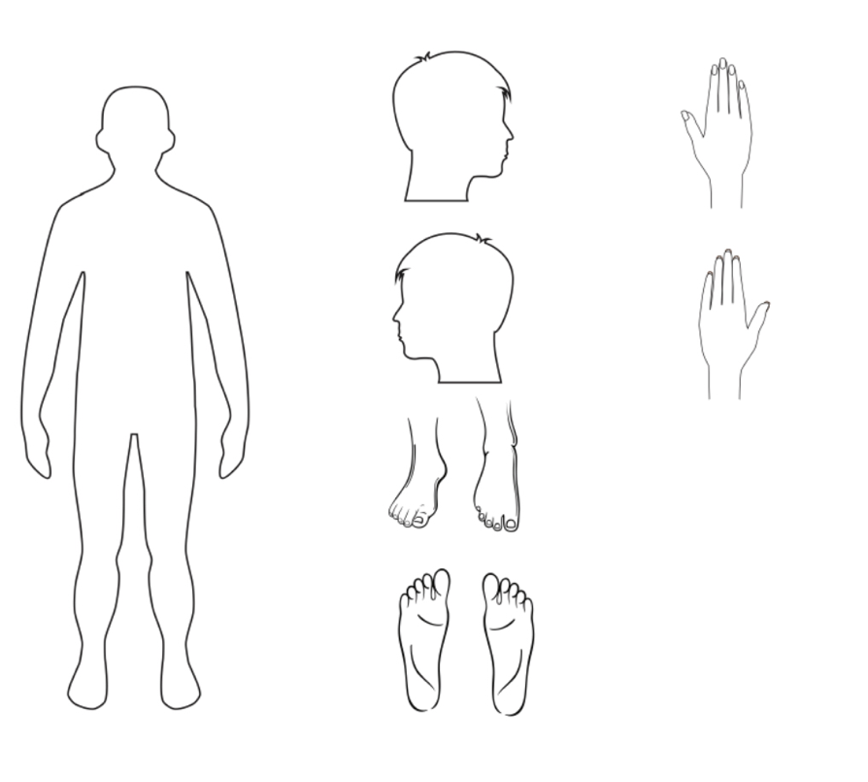*Please use the body map provided if useful*

Continued from overleaf…

Form Reference